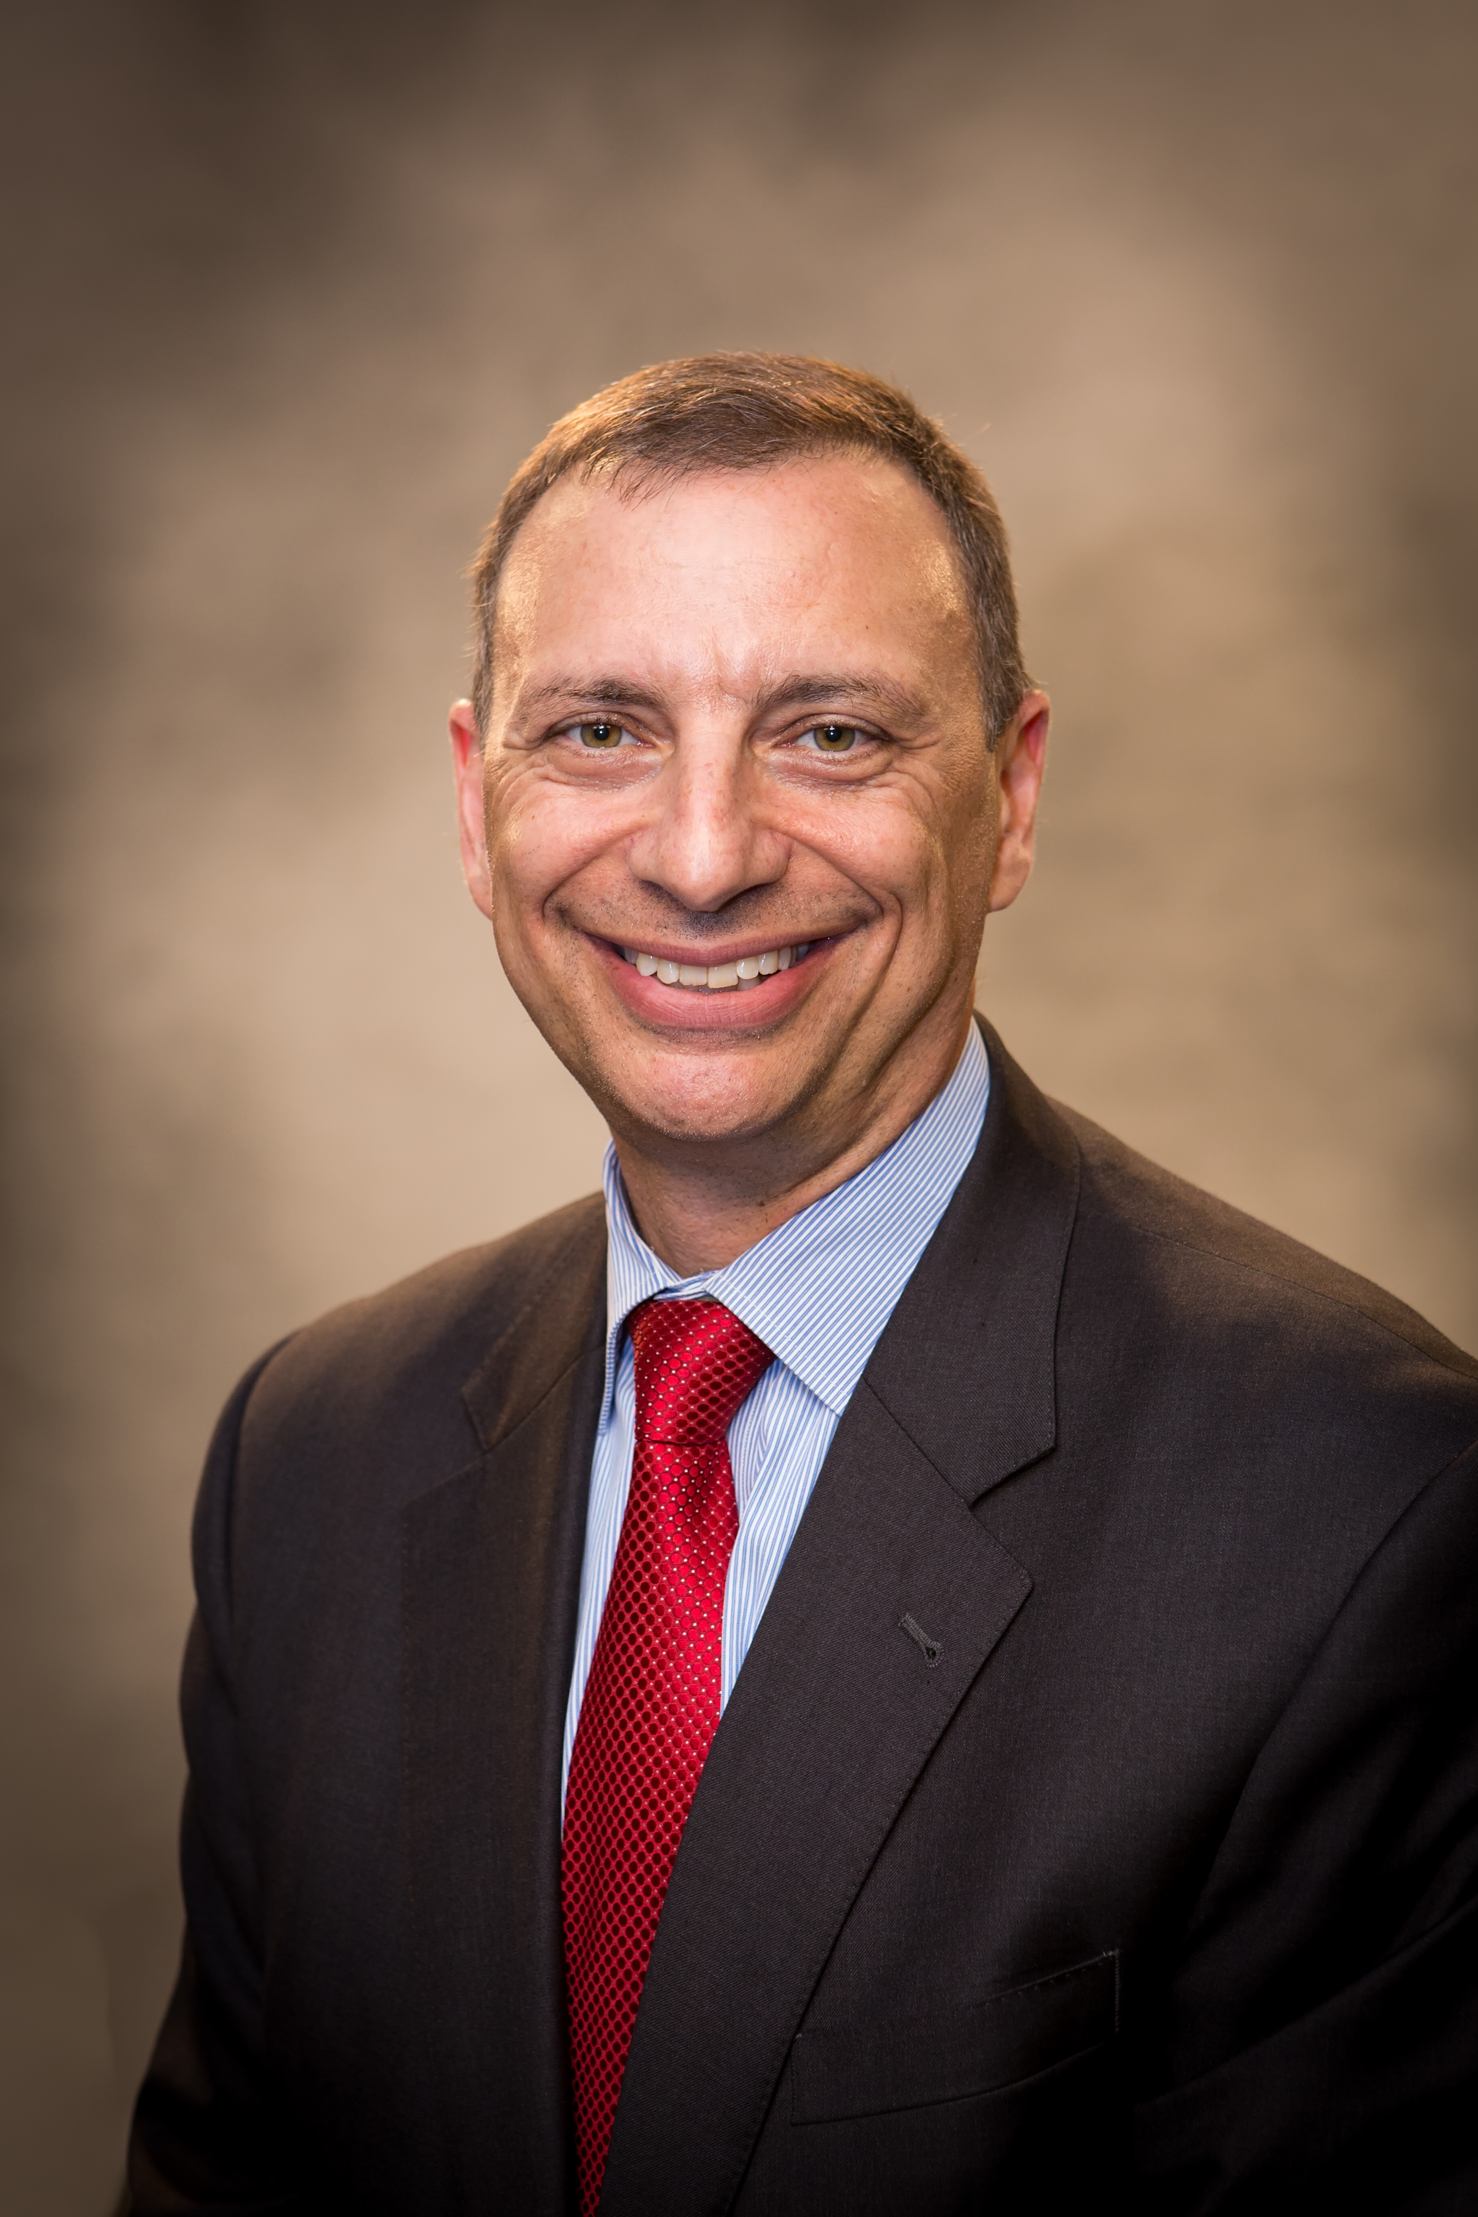

BRIAN FISHEL
Senior Vice President, Head of Talent Management & Talent Acquisition
KeyBank

Brian Fishel has over 25 years of broad Human Resources experience across multiple industries. He has specific expertise in the areas of Global Talent Management, Executive Assessment, Development and Coaching, Succession Planning and Team Effectiveness, and Merger-Acquisition and Culture Integration at the senior most levels of organizations, as well as Staffing and Organization Development.

In his current role, Brian leads all staffing and talent management activities for Key Bank.

Prior to joining Key in 2013, Brian spent 15 years with Bank of America in various senior level talent management and organization development roles, including the Global Head of Executive Development and Chief Learning Officer for the enterprise.

Prior to Bank of America, Mr. Fishel held various senior-level Human Resource Generalist roles with The Coca-Cola Company providing human capital advisory support for their Global Marketing, Communications and Finance Functions, The Minute Maid Group, and International Bottling operations.

Before Coca-Cola, Brian worked for Pizza Hut, at the time a subsidiary of PepsiCo. He was responsible for designing and delivering Pizza Hut's executive development curriculum targeted at their senior level field sales and operations executives throughout North America. He also led their U.S. field sales and operations training organization.

Brian is a frequent national speaker on the topics of Talent Management and Executive Development. He is a founding member of the Best Practice Institute’s board, and has served on the Harvard Publishing Advisory Committee and the Conference Board’s Learning and Organizational Performance roundtable. He has written and published several articles and chapters in various books and magazines on an variety of Leadership topics.

Brian holds both a Bachelors and Masters of Science in Education from Miami University of Ohio.

